SIH 2025

AI Dropout Prediction

TasselTurners

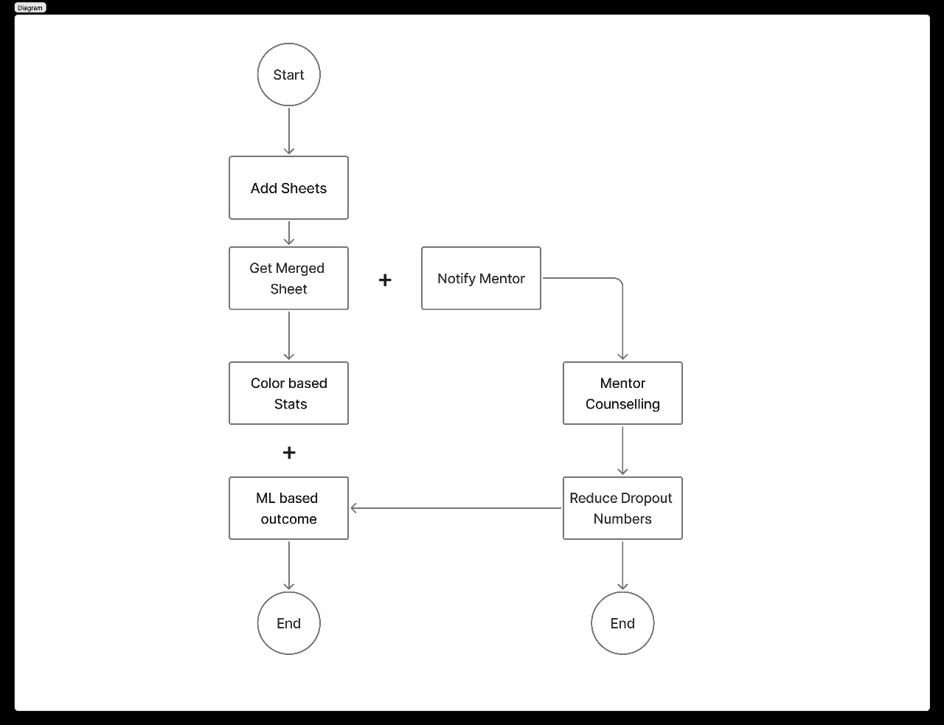Simple Workflow Chart

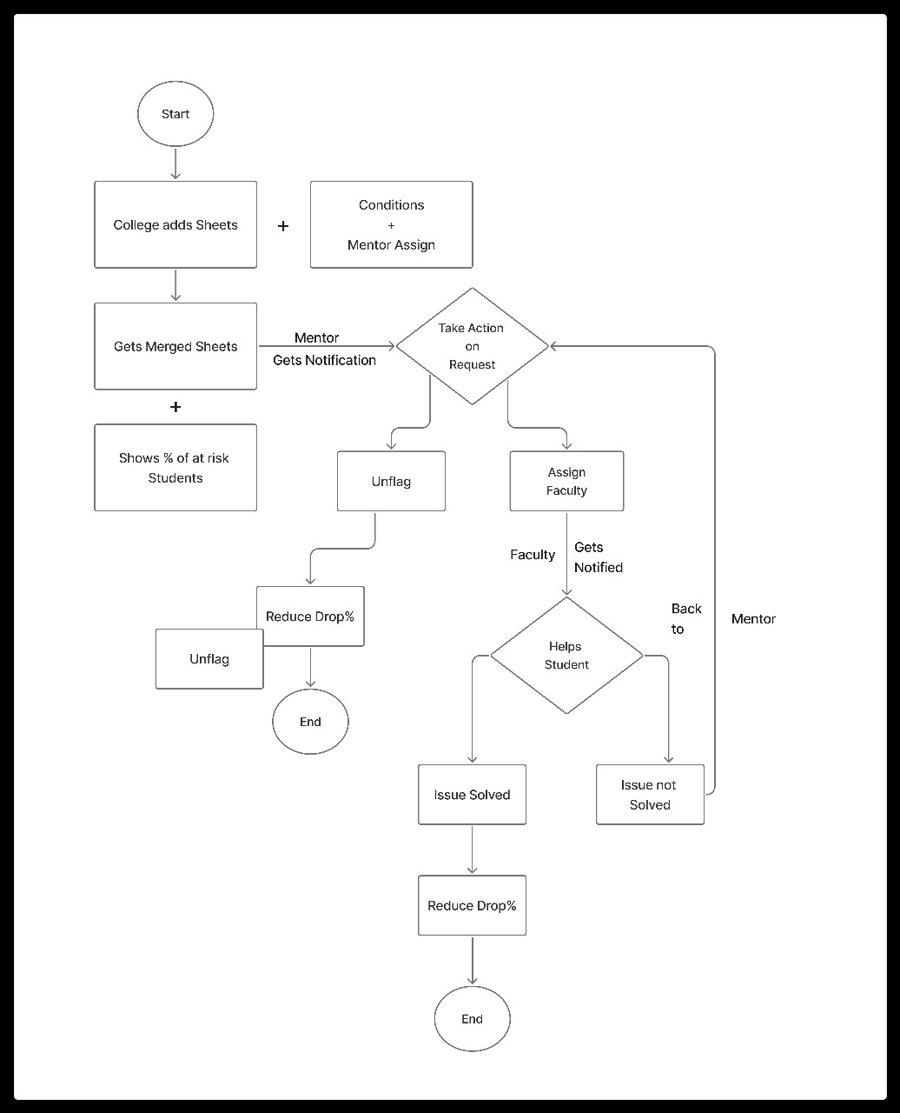Role-Based Workflow Chart

Entity – Relationship Diagram 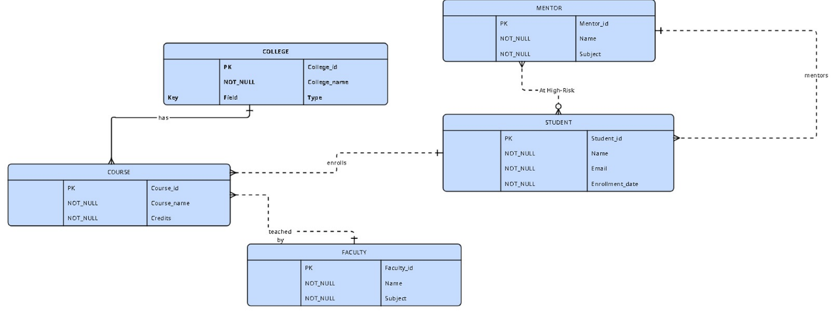

Entity – Relationship Diagram (Some Modification)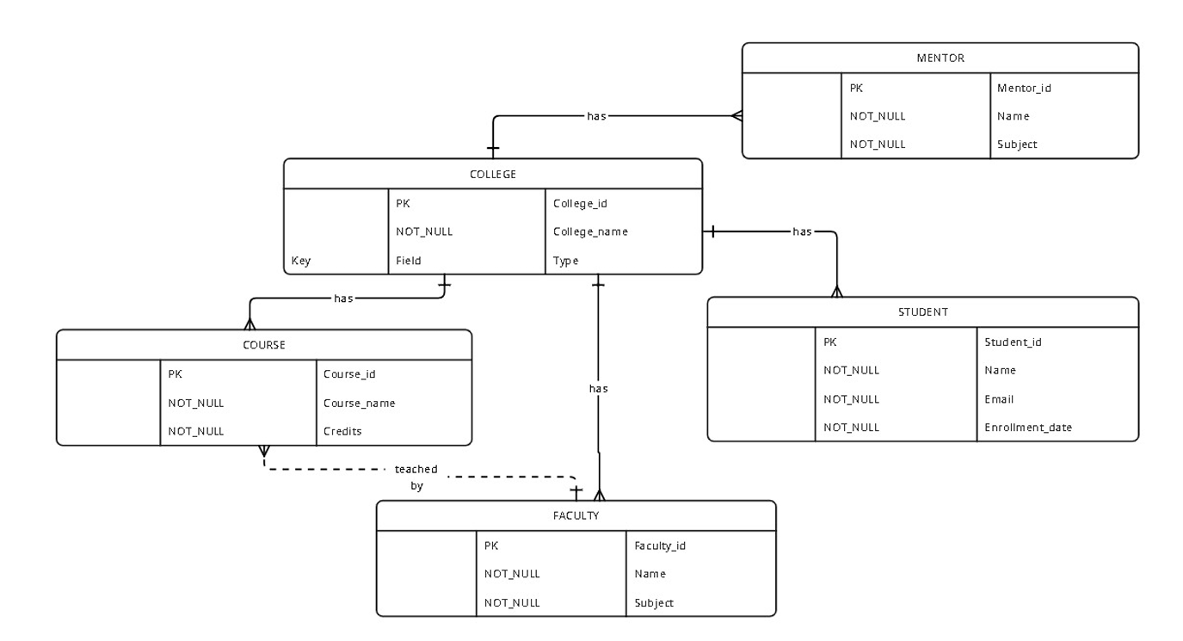

Entity – Relationship Diagram (Optional)

